**DOMAIN CONFIGURATION**

**VM:**

If the application is accessing through Apache tomcat which is installed in vm instance it will be accessing with VM external IP and port 8080

Ex: 36.172.198.56:8080

1. Go to mic-canada-dev project and navigate to vm instance.
2. Open SSH browser and follow below commands to reach reverse_proxy_ssl.conf file.

Cd /etc/nginx/conf.d/

Vi reverse_proxy_ssl.conf

1. Add the following lines and edit the reuired fields like url and ip address.

server {

listen 443 http2 ssl;

listen [::]:443 http2 ssl;

server_name **apps.micnxt.com**;

access_log /var/log/nginx/**apps**_access.log;

error_log /var/log/nginx/**apps**_error.log;

location / {

proxy_set_header Host **apps.micnxt.com**;

proxy_pass **http://104.197.128.64:8080**;

}

ssl_certificate /etc/apache2/certs/a3348c4753956cbb.pem;

ssl_certificate_key /etc/apache2/certs/generated-private-key_MICNXT.key;

}

1. After adding restart the nginx service by using below command.

sudo service nginx restart

**CHATBOT DEPLOYMENT (Bucket)**

If the application is deployed in bucket for a chatbot we need to create load balance to the bucket.

Load balancer creation for bucket:

1. Navigate to load balancing page in network service in GCP. 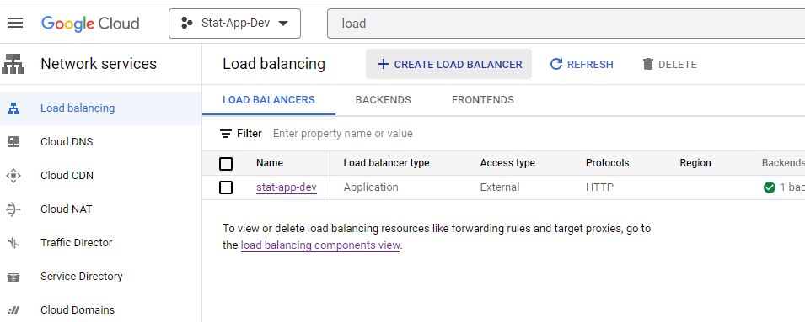
2. Click on create load balancer and select application load balancer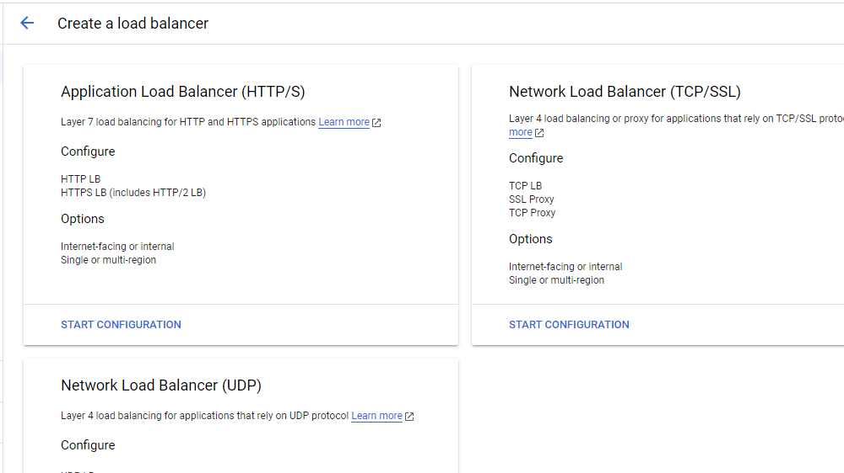

**Cloud DNS:**

1. Go to cloud dns in mic-canada-dev 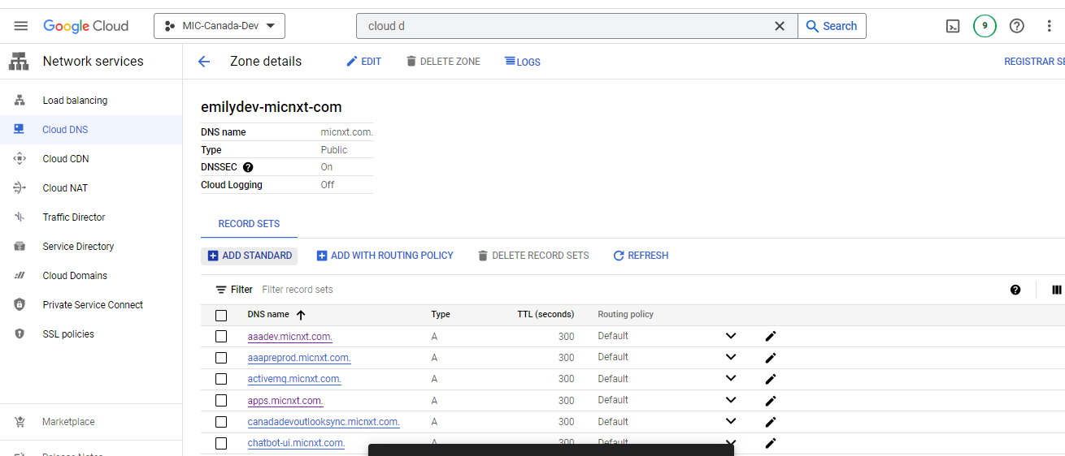
2. Click on add standard to add subdomain name
3. Add DNS name of what we required
4. IP address of mic-canada-dev VM in which nginx is there now click on create.

